**1.Introduction**

While HTML and CSS handle the structure and presentation of web pages, PHP (Hypertext Preprocessor) adds interactivity and functionality. PHP is a server-side scripting language used to generate dynamic content. It performs tasks like processing forms, managing user authentication, and interacting with databases.PHP scripts are executed on the web server before the HTML is sent to the client’s browser. The server-side processing enables PHP to generate dynamic content based on user input or database queries, making web applications more robust and interactive.Syntax and Basic Constructs in PHPPHP uses a PHP-enabled script file (typically with a .php extension) that contains PHP code embedded within HTML. PHP code is enclosed in <?php and ?> tags.

**1.1Objective**

Use HTML when creating static web pages without needing interactivity or dynamic content. Ideal for informational websites, brochures, or landing pages where content rarely changes. When to Incorporate CSS for Styling: Employ CSS when you want to enhance your web pages’ visual design and layout. It is essential for creating responsive designs that adapt to different screen sizes and devices. Use CSS to maintain a consistent brand identity and user experience. Situations Where PHP Adds Interactivity Use PHP when building web applications that require user input processing, authentication, or database interactions. PHP is invaluable for creating content management systems (CMS), e-commerce platforms, forums, and other dynamic web applications. Choose PHP for scenarios where content needs to change based on user interactions or database updates.

**1.2Problem statement**

To Create a responsive website using php, html, css. Include the database and integration. insert map, form in it.

**1.3 Project Scope**

Anyone who aspires to be a Web Designer could join, various short duration courses for Web Designing Training. Learn the course professionally and become a professional Web Designer. The course duration is from 6 months to one year. In this course, you will learn about HTML, PHP, CSS, Dreamweaver, Magneto, Word press, and Photoshop. Once you have completed a master’s in this field. You can begin your career in reputedThe main career areas in this field include: Front end developer Back end developerPrimary roles of a Frontend and Backend Developer Front end developerThe client-side dealing is usually operated by the front end developer with the graphics, web page design which is accessible to the user.Back end developer The back end development which interacts with the server is operated by the back end developer. PHP, ASP.Net, Java, Cold Fusion, and Perl are the types of languages that are specialized by the Back End Web developer.

**2.System Architecture**

Following diagram represents architecture

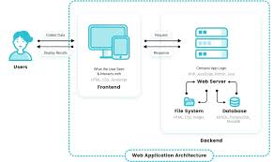

Web architecture refers to the overall structure of a website or web application, including the way it is designed, implemented, and deployed. It involves the use of technologies and protocols such as HTML, CSS, JavaScript, and HTTP to build and deliver web pages and applications to users.Web architecture consists of several components, including the client, the server, the network, and the database. The client is the web browser or application that the user interacts with, and the server is the computer or group of computers that host the website or web application. The network is the infrastructure that connects the the client and the server, such as the internet. The database is a collection of data that is used to store and retrieve information for the website or web application.Web architecture also includes the design and layout of the website or web application, as well as the way it is organized and the relationships between different pages and components. It also includes the way the website or web application is built and maintained, including the use of frameworks and libraries, and the deployment and hosting of the website .There are several components that make up a web architecture –

The client −This is the web browser or application that the user interacts with. The client sends requests to the server and receives responses from the server.

The server −This is the computer or group of computers that host the website or web application. The server processes requests from the client and sends back the appropriate response.

The network This is the infrastructure that connects the client and the server, such as the internet. It allows for communication between the client and the server.

The database −This is a collection of data that is used to store and retrieve information for the website or web application. The database can be located on the same server as the website or web application, or it can be hosted on a separate server.

The design and layout −This refers to the way the website or web application is structured and organized, including the layout, navigation, and overall appearance.

The frameworks and libraries − These are tools and resources that are used to build and maintain the website or web application. They can include frameworks like Ruby on Rails or Django, or libraries like jQuery or React.

The deployment and hosting − This refers to the way the website or web application is deployed and hosted, including the hosting environment (such as a shared hosting plan or a cloud platform) and the process for deploying updates and changes to the website or web application.

**3.Algorithm**

First, You need to know the basic definitions of:

1. HTML — is the markup language used for structuring and presenting content on the World Wide Web.

2. CSS — describes how HTML elements are to be displayed on a screen, paper, or in other media.

3. PHP — is a highly popular server-side scripting language. It is very flexible It is very flexible and has a lot of innovative features. It is the fastest resource available for creating database-enabled dynamic websites.

4. MySQL — is a database management system based on Structured Query Language (SQL) which is used in web applications.

And for me, I have a simple definition:

HTML,CSS= **Front-End**

•PHP,MySQL= **Back-End**

Below is the screenshot of profile of online driving school portal

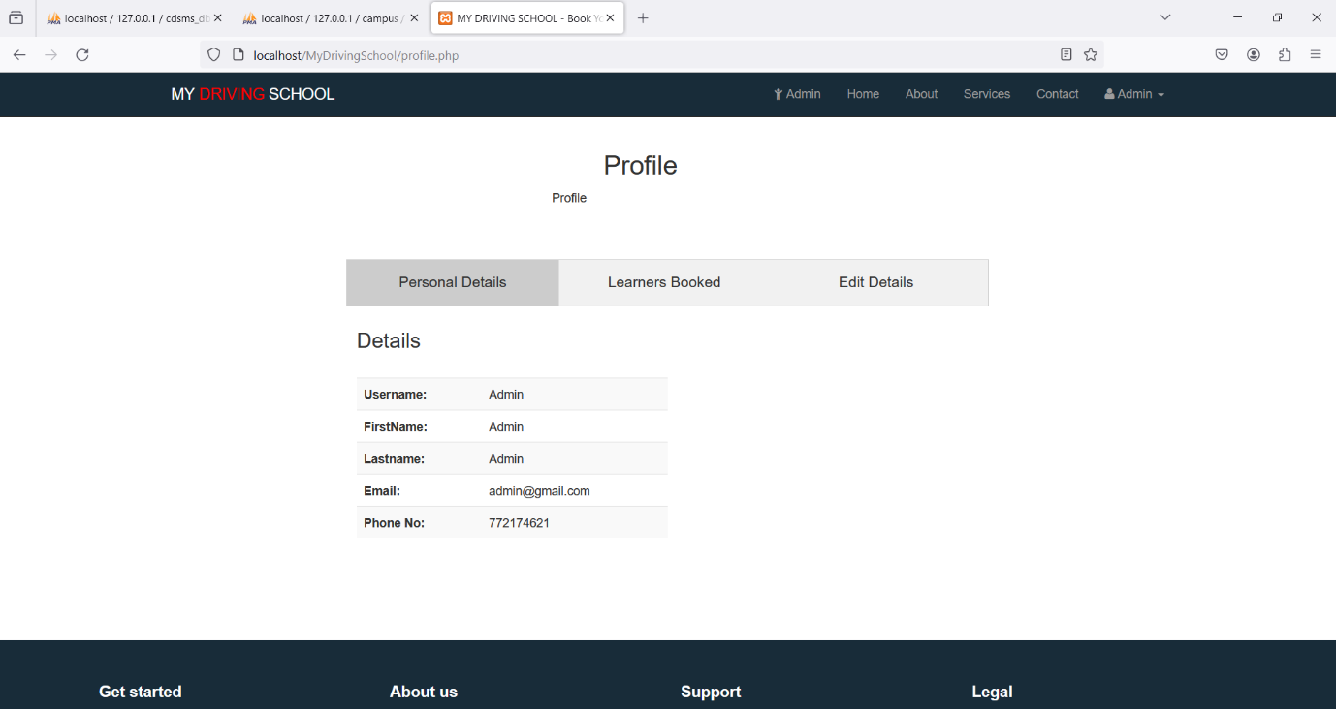

Then we have a login page of learners.here they can enter the district and see the nearby classes available in their vicinity.

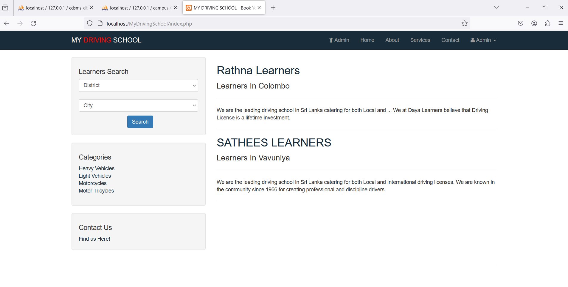

Below is the admin page where in all the added customer data is visible for the administrator to handle.

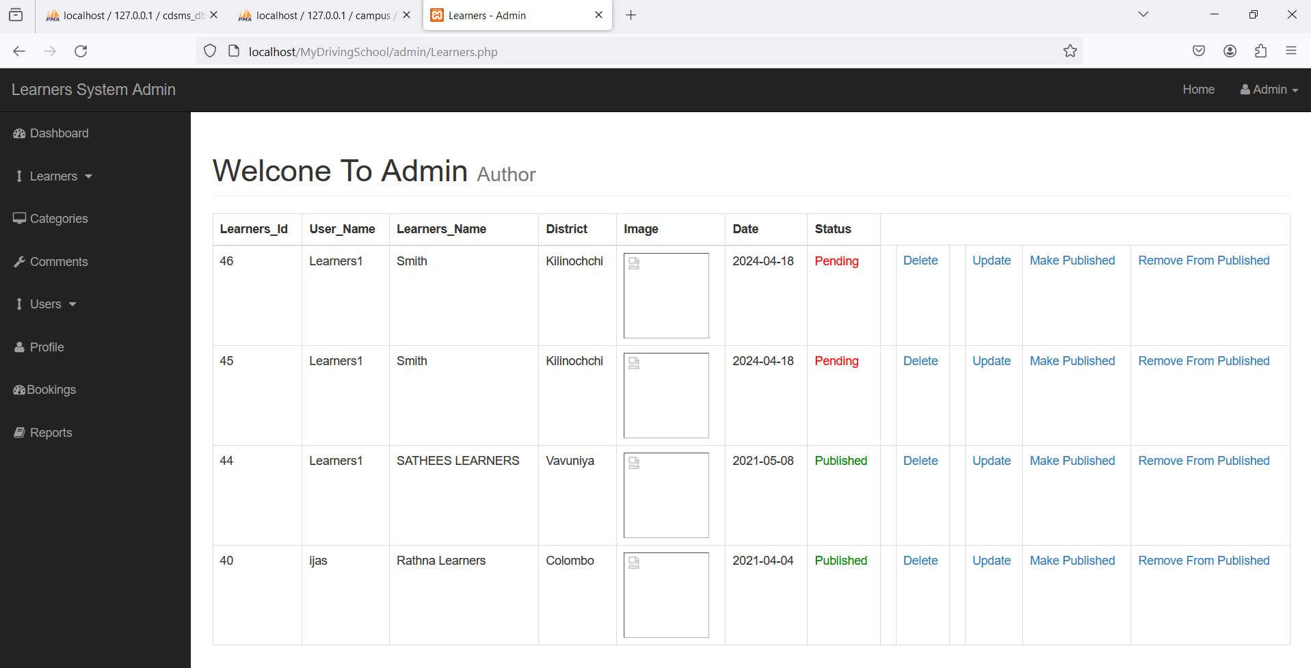

Below is the registration form visible to client to fill in the details of the desired course they want to enroll in for.

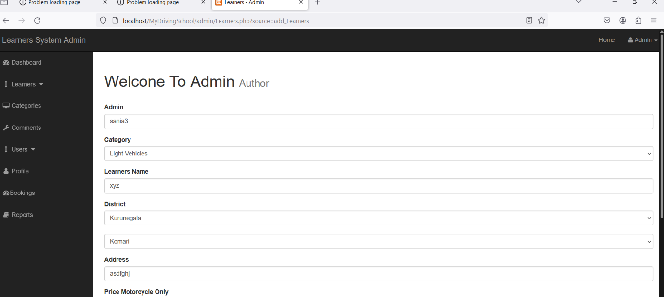

Here we can see the phpMyAdmin page where the backend is integrated and all the records are visible here whichever are enrolled on the front end.

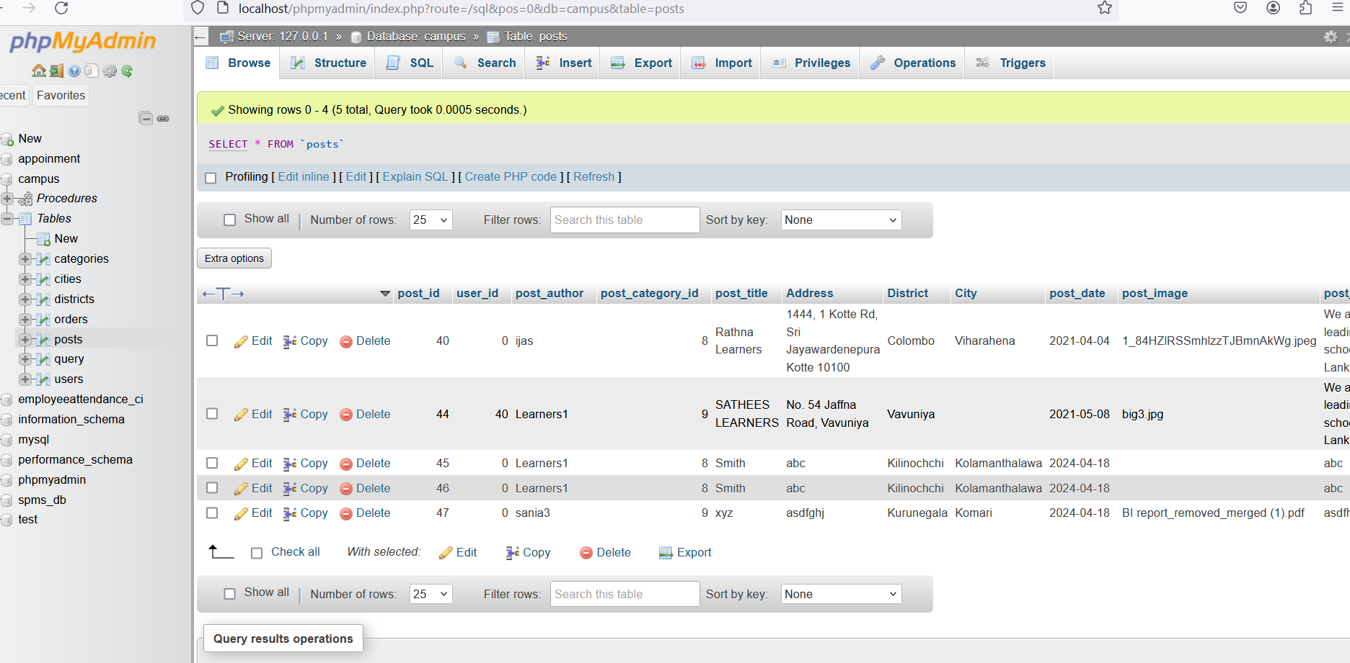

Below is the screenshort of all the cities added to choose for the customer to enroll in.

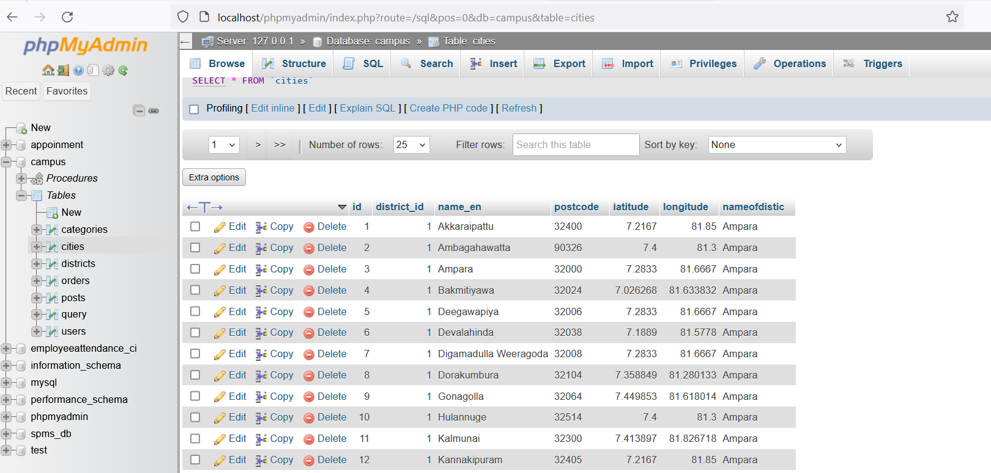

Below is the screenshort of the records enrolled on this website

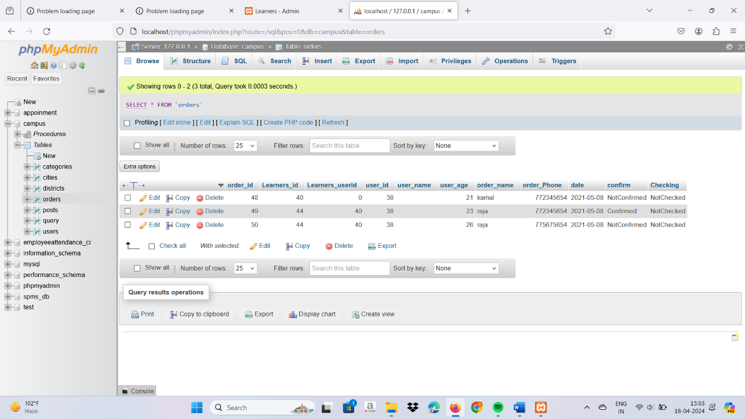

**4.Dataflow diagram**

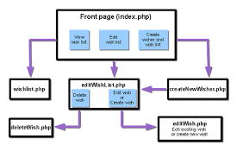

**5.Coding**

<!DOCTYPE html>

<html lang="en">

<head>

<meta charset="utf-8">

<meta content="width=device-width, initial-scale=1.0" name="viewport">

<title>About - Company Bootstrap Template</title>

<meta content="" name="description">

<meta content="" name="keywords">

<!-- Favicons -->

<link href="assets/img/favicon.png" rel="icon">

<link href="assets/img/apple-touch-icon.png" rel="apple-touch-icon">

<!-- Google Fonts -->

<link href="https://fonts.googleapis.com/css?family=Open+Sans:300,300i,400,400i,600,600i,700,700i|Roboto:300,300i,400,400i,500,500i,600,600i,700,700i|Poppins:300,300i,400,400i,500,500i,600,600i,700,700i" rel="stylesheet">

<!-- Vendor CSS Files -->

<link href="assets/vendor/animate.css/animate.min.css" rel="stylesheet">

<link href="assets/vendor/aos/aos.css" rel="stylesheet">

<link href="assets/vendor/bootstrap/css/bootstrap.min.css" rel="stylesheet">

<link href="assets/vendor/bootstrap-icons/bootstrap-icons.css" rel="stylesheet">

<link href="assets/vendor/boxicons/css/boxicons.min.css" rel="stylesheet">

<link href="assets/vendor/glightbox/css/glightbox.min.css" rel="stylesheet">

<link href="assets/vendor/remixicon/remixicon.css" rel="stylesheet">

<link href="assets/vendor/swiper/swiper-bundle.min.css" rel="stylesheet">

<!-- Template Main CSS File -->

<link href="assets/css/style.css" rel="stylesheet">

<!-- =======================================================

* Template Name: Company

* Updated: Jan 29 2024 with Bootstrap v5.3.2

* Template URL: https://bootstrapmade.com/company-free-html-bootstrap-template/

* Author: BootstrapMade.com

* License: https://bootstrapmade.com/license/

======================================================== -->

</head>

<body>

<!-- ======= Header ======= -->

<header id="header" class="fixed-top">

<div class="container d-flex align-items-center">

<h1 class="logo me-auto"><a href="index.html"><span>Com</span>pany</a></h1>

<!-- Uncomment below if you prefer to use an image logo -->

<!-- <a href="index.html" class="logo me-auto me-lg-0"><img src="assets/img/logo.png" alt="" class="img-fluid"></a>-->

<nav id="navbar" class="navbar order-last order-lg-0">

<ul>

<li><a href="index.html">Home</a></li>

<li class="dropdown"><a href="#"><span>About</span> <i class="bi bi-chevron-down"></i></a>

<ul>

<li><a href="about.html" class="active">About Us</a></li>

<li><a href="team.html">Team</a></li>

<li><a href="testimonials.html">Testimonials</a></li>

<li class="dropdown"><a href="#"><span>Deep Drop Down</span> <i class="bi bi-chevron-right"></i></a>

<ul>

<li><a href="#">Deep Drop Down 1</a></li>

<li><a href="#">Deep Drop Down 2</a></li>

<li><a href="#">Deep Drop Down 3</a></li>

<li><a href="#">Deep Drop Down 4</a></li>

<li><a href="#">Deep Drop Down 5</a></li>

</ul>

</li>

</ul>

</li>

<li><a href="services.html">Services</a></li>

<li><a href="portfolio.html">Portfolio</a></li>

<li><a href="pricing.html">Pricing</a></li>

<li><a href="blog.html">Blog</a></li>

<li><a href="contact.html">Contact</a></li>

</ul>

<i class="bi bi-list mobile-nav-toggle"></i>

</nav><!-- .navbar -->

<div class="header-social-links d-flex">

<a href="#" class="twitter"><i class="bu bi-twitter"></i></a>

<a href="#" class="facebook"><i class="bu bi-facebook"></i></a>

<a href="#" class="instagram"><i class="bu bi-instagram"></i></a>

<a href="#" class="linkedin"><i class="bu bi-linkedin"></i></i></a>

</div>

</div>

</header><!-- End Header -->

<main id="main">

<!-- ======= Contact Section ======= -->

<div class="map-section">

<iframe style="border:0; width: 100%; height: 350px;" src="https://www.google.com/maps/embed?pb=!1m14!1m8!1m3!1d12097.433213460943!2d-74.0062269!3d40.7101282!3m2!1i1024!2i768!4f13.1!3m3!1m2!1s0x0%3A0xb89d1fe6bc499443!2sDowntown+Conference+Center!5e0!3m2!1smk!2sbg!4v1539943755621" frameborder="0" allowfullscreen></iframe>

</div>

<section id="contact" class="contact">

<div class="container">

<div class="row justify-content-center" data-aos="fade-up">

<div class="col-lg-10">

<div class="info-wrap">

<div class="row">

<div class="col-lg-4 info">

<i class="bi bi-geo-alt"></i>

<h4>Location:</h4>

<p>A108 Adam Street<br>New York, NY 535022</p>

</div>

<div class="col-lg-4 info mt-4 mt-lg-0">

<i class="bi bi-envelope"></i>

<h4>Email:</h4>

<p>info@example.com<br>contact@example.com</p>

</div>

<div class="col-lg-4 info mt-4 mt-lg-0">

<i class="bi bi-phone"></i>

<h4>Call:</h4>

<p>+1 5589 55488 51<br>+1 5589 22475 14</p>

</div>

</div>

</div>

</div>

</div>

<div class="row mt-5 justify-content-center" data-aos="fade-up">

<div class="col-lg-10">

<form action="forms/contact.php" method="post" role="form" class="php-email-form">

<div class="row">

<div class="col-md-6 form-group">

<input type="text" name="name" class="form-control" id="name" placeholder="Your Name" required>

</div>

<div class="col-md-6 form-group mt-3 mt-md-0">

<input type="email" class="form-control" name="email" id="email" placeholder="Your Email" required>

</div>

</div>

<div class="form-group mt-3">

<input type="text" class="form-control" name="subject" id="subject" placeholder="Subject" required>

</div>

<div class="form-group mt-3">

<textarea class="form-control" name="message" rows="5" placeholder="Message" required></textarea>

</div>

<div class="my-3">

<div class="loading">Loading</div>

<div class="error-message"></div>

<div class="sent-message">Your message has been sent. Thank you!</div>

</div>

<div class="text-center"><button type="submit">Send Message</button></div>

</form>

</div>

</div>

</div>

</section><!-- End Contact Section -->

</main><!-- End #main -->

/*services*/

        <div class="row">

          <div class="col-lg-4 col-md-6 d-flex align-items-stretch" data-aos="zoom-in" data-aos-delay="100">

            <div class="icon-box iconbox-blue">

              <div class="icon">

                <svg width="100" height="100" viewBox="0 0 600 600" xmlns="http://www.w3.org/2000/svg">

                  <path stroke="none" stroke-width="0" fill="#f5f5f5" d="M300,521.0016835830174C376.1290562159157,517.8887921683347,466.0731472004068,529.7835943286574,510.70327084640275,468.03025145048787C554.3714126377745,407.6079735673963,508.03601936045806,328.9844924480964,491.2728898941984,256.3432110539036C474.5976632858925,184.082847569629,479.9380746630129,96.60480741107993,416.23090153303,58.64404602377083C348.86323505073057,18.502131276798302,261.93793281208167,40.57373210992963,193.5410806939664,78.93577620505333C130.42746243093433,114.334589627462,98.30271207620316,179.96522072025542,76.75703585869454,249.04625023123273C51.97151888228291,328.5150500222984,13.704378332031375,421.85034740162234,66.52175969318436,486.19268352777647C119.04800174914682,550.1803526380478,217.28368757567262,524.383925680826,300,521.0016835830174"></path>

                </svg>

                <i class="bx bxl-dribbble"></i>

              </div>

              <h4><a href="">NORTH INDIAN</a></h4>

              <p><li>Paneer tikka masala     250</li>

                <li>Panner butter masala     250</li>

                <li>Paneer bhurji            240</li>

                <li> Malai kofta             260</li>

                <li>Alu mattar               200</li>

                <li>Baby corn kadai          190</li>

                <li>Bhendi masala            150</li>

                <li>Chana masala             150</li>

                <li>Navratna kurma           150</li>

                <li>Dum kashmiri aloo        150</li>

              </p>

            </div>

          </div>

          <div class="col-lg-4 col-md-6 d-flex align-items-stretch mt-4 mt-md-0" data-aos="zoom-in" data-aos-delay="200">

            <div class="icon-box iconbox-orange ">

              <div class="icon">

                <svg width="100" height="100" viewBox="0 0 600 600" xmlns="http://www.w3.org/2000/svg">

                  <path stroke="none" stroke-width="0" fill="#f5f5f5" d="M300,582.0697525312426C382.5290701553225,586.8405444964366,449.9789794690241,525.3245884688669,502.5850820975895,461.55621195738473C556.606425686781,396.0723002908107,615.8543463187945,314.28637112970534,586.6730223649479,234.56875336149918C558.9533121215079,158.8439757836574,454.9685369536778,164.00468322053177,381.49747125262974,130.76875717737553C312.15926192815925,99.40240125094834,248.97055460311594,18.661163978235184,179.8680185752513,50.54337015887873C110.5421016452524,82.52863877960104,119.82277516462835,180.83849132639028,109.12597500060166,256.43424936330496C100.08760227029461,320.3096726198365,92.17705696193138,384.0621239912766,124.79988738764834,439.7174275375508C164.83382741302287,508.01625554203684,220.96474134820875,577.5009287672846,300,582.0697525312426"></path>

                </svg>

                <i class="bx bx-file"></i>

              </div>

              <h4><a href="">SOUTH INDIAN</a></h4>

              <p><li>Pongal       200</li>

                <li>Masala dosa   60</li>

                  <li>idli        40</li>

                  <li>Chicken 65  250</li>

                    <li>Sambar rice 120</li>

                      <li>Pulihora   130</li>

                        <li>Appam     90</li>

                        <li>Rassam rice  120</li>

                          <li>Upma        60</li>

                            <li>Hyderabadi biryani  350</p></li>

            </div>

          </div>

          <div class="col-lg-4 col-md-6 d-flex align-items-stretch mt-4 mt-lg-0" data-aos="zoom-in" data-aos-delay="300">

            <div class="icon-box iconbox-pink">

              <div class="icon">

                <svg width="100" height="100" viewBox="0 0 600 600" xmlns="http://www.w3.org/2000/svg">

                  <path stroke="none" stroke-width="0" fill="#f5f5f5" d="M300,541.5067337569781C382.14930387511276,545.0595476570109,479.8736841581634,548.3450877840088,526.4010558755058,480.5488172755941C571.5218469581645,414.80211281144784,517.5187510058486,332.0715597781072,496.52539010469104,255.14436215662573C477.37192572678356,184.95920475031193,473.57363656557914,105.61284051026155,413.0603344069578,65.22779650032875C343.27470386102294,18.654635553484475,251.2091493199835,5.337323636656869,175.0934190732945,40.62881213300186C97.87086631185822,76.43348514350839,51.98124368387456,156.15599469081315,36.44837278890362,239.84606092416172C21.716077023791087,319.22268207091537,43.775223500013084,401.1760424656574,96.891909868211,461.97329694683043C147.22146801428983,519.5804099606455,223.5754009179313,538.201503339737,300,541.5067337569781"></path>

                </svg>

                <i class="bx bx-tachometer"></i>

              </div>

              <h4><a href="">EAST INDIAN</a></h4>

              <p><li>Litti Chokha    150</li>

                <li>Machcher Jhol    150</li>

                <li>Chorchori        120</li>

                <li>Dalma            110</li>

                <li>Assamese Fish Curry   350</li>

                <li>Momos             110</li>

                <li>Thukpa            180</li>

                <li>Manipuri Kelli chana   180</li>

                <li>Assamese ghingri fry   250</li>

                <li>Bangun bhaja       110</li>

              </p>

            </div>

          </div>

          <div class="col-lg-4 col-md-6 d-flex align-items-stretch mt-4" data-aos="zoom-in" data-aos-delay="100">

            <div class="icon-box iconbox-yellow">

              <div class="icon">

                <svg width="100" height="100" viewBox="0 0 600 600" xmlns="http://www.w3.org/2000/svg">

                  <path stroke="none" stroke-width="0" fill="#f5f5f5" d="M300,503.46388370962813C374.79870501325706,506.71871716319447,464.8034551963731,527.1746412648533,510.4981551193396,467.86667711651364C555.9287308511215,408.9015244558933,512.6030010748507,327.5744911775523,490.211057578863,256.5855673507754C471.097692560561,195.9906835881958,447.69079081568157,138.11976852964426,395.19560036434837,102.3242989838813C329.3053358748298,57.3949838291264,248.02791733380457,8.279543830951368,175.87071277845988,42.242879143198664C103.41431057327972,76.34704239035025,93.79494320519305,170.9812938413882,81.28167332365135,250.07896920659033C70.17666984294237,320.27484674793965,64.84698225790005,396.69656628748305,111.28512138212992,450.4950937839243C156.20124167950087,502.5303643271138,231.32542653798444,500.4755392045468,300,503.46388370962813"></path>

                </svg>

                <i class="bx bx-layer"></i>

              </div>

              <h4><a href="">WEST INDIAN</a></h4>

              <p><li>Zunka bhakar   150</li>

                <li>Misal pav       150</li>

                  <li>Pav bhaji     150</li>

                    <li>Goan fish Curry   350</li>

                      <li>Goan chicken cutlet  250</li>

                        <li>Gatte ki sabji   110</li>

                          <li>Methi ke theple   60</li>

                            <li>Bebinca     90</li>

                              <li>Vada pav    20</li>

                                <li>Bombay duck   350</li>

              </p>

            </div>

          </div>

          <div class="col-lg-4 col-md-6 d-flex align-items-stretch mt-4" data-aos="zoom-in" data-aos-delay="200">

            <div class="icon-box iconbox-red">

              <div class="icon">

                <svg width="100" height="100" viewBox="0 0 600 600" xmlns="http://www.w3.org/2000/svg">

                  <path stroke="none" stroke-width="0" fill="#f5f5f5" d="M300,532.3542879108572C369.38199826031484,532.3153073249985,429.10787420159085,491.63046689027357,474.5244479745417,439.17860296908856C522.8885846962883,383.3225815378663,569.1668002868075,314.3205725914397,550.7432151929288,242.7694973846089C532.6665558377875,172.5657663291529,456.2379748765914,142.6223662098291,390.3689995646985,112.34683881706744C326.66090330228417,83.06452184765237,258.84405631176094,53.51806209861945,193.32584062364296,78.48882559362697C121.61183558270385,105.82097193414197,62.805066853699245,167.19869350419734,48.57481801355237,242.6138429142374C34.843463184063346,315.3850353017275,76.69343916112496,383.4422959591041,125.22947124332185,439.3748458443577C170.7312796277747,491.8107796887764,230.57421082200815,532.3932930995766,300,532.3542879108572"></path>

                </svg>

                <i class="bx bx-slideshow"></i>

              </div>

              <h4><a href="">ROTIS/RICE</a></h4>

              <p><li>Chapati  10</li>

                <li>Roti      15</li>

                <li>Naan      20</li>

                <li>Butter naan     25</li>

                <li>Plain rice   40</li>

                <li>Geera rice   50</li>

                <li>Biryani      250</li>

                <li>Pulaw         180</li>

                <li>Fried rice     160</li>

                <li>Coconut rice    150</li>

              </p>

            </div>

          </div>

          <div class="col-lg-4 col-md-6 d-flex align-items-stretch mt-4" data-aos="zoom-in" data-aos-delay="300">

            <div class="icon-box iconbox-teal">

              <div class="icon">

                <svg width="100" height="100" viewBox="0 0 600 600" xmlns="http://www.w3.org/2000/svg">

                  <path stroke="none" stroke-width="0" fill="#f5f5f5" d="M300,566.797414625762C385.7384707136149,576.1784315230908,478.7894351017131,552.8928747891023,531.9192734346935,484.94944893311C584.6109503024035,417.5663521118492,582.489472248146,322.67544863468447,553.9536738515405,242.03673114598146C529.1557734026468,171.96086150256528,465.24506316201064,127.66468636344209,395.9583748389544,100.7403814666027C334.2173773831606,76.7482773500951,269.4350130405921,84.62216499799875,207.1952322260088,107.2889140133804C132.92018162631612,134.33871894543012,41.79353780512637,160.00259165414826,22.644507872594943,236.69541883565114C3.319112789854554,314.0945973066697,72.72355303640163,379.243833228382,124.04198916343866,440.3218312028393C172.9286146004772,498.5055451809895,224.45579914871206,558.5317968840102,300,566.797414625762"></path>

                </svg>

                <i class="bx bx-arch"></i>

              </div>

              <h4><a href="">DESERTS/BEVERAGES</a></h4>

              <p><li>Shrikhanda    100</li>

                <li>Ghewar          50</li>

                <li>Ice-creams(family pack)   150</li>

                <li>Cold drinks      80</li>

                <li>Gulabjamun      90</li>

                <li>Lassi           50</li>

                <li>Matanis          120</li>

                <li>Rabdi          150</li>

                <li>Tak             50</li>

                <li>Basundi         150</li>

                </p>

            </div>

          </div>

        </div>

      </div>

    </section><!-- End Services Section -->

    <!-- ======= Features Section ======= -->

    <section id="features" class="features">

      <div class="container" data-aos="fade-up">

        <div class="section-title">

          <h2>Features</h2>

          <p>Magnam dolores commodi suscipit. Necessitatibus eius consequatur ex aliquid fuga eum quidem. Sit sint consectetur velit. Quisquam quos quisquam cupiditate. Et nemo qui impedit suscipit alias ea. Quia fugiat sit in iste officiis commodi quidem hic quas.</p>

        </div>

        <div class="row">

          <div class="col-lg-3 col-md-4">

            <div class="icon-box">

              <i class="ri-store-line" style="color: #ffbb2c;"></i>

              <h3><a href="">Lorem Ipsum</a></h3>

            </div>

          </div>

          <div class="col-lg-3 col-md-4 mt-4 mt-md-0">

            <div class="icon-box">

              <i class="ri-bar-chart-box-line" style="color: #5578ff;"></i>

              <h3><a href="">Dolor Sitema</a></h3>

            </div>

          </div>

          <div class="col-lg-3 col-md-4 mt-4 mt-md-0">

            <div class="icon-box">

              <i class="ri-calendar-todo-line" style="color: #e80368;"></i>

              <h3><a href="">Sed perspiciatis</a></h3>

            </div>

          </div>

          <div class="col-lg-3 col-md-4 mt-4 mt-lg-0">

            <div class="icon-box">

              <i class="ri-paint-brush-line" style="color: #e361ff;"></i>

              <h3><a href="">Magni Dolores</a></h3>

            </div>

          </div>

          <div class="col-lg-3 col-md-4 mt-4">

            <div class="icon-box">

              <i class="ri-database-2-line" style="color: #47aeff;"></i>

              <h3><a href="">Nemo Enim</a></h3>

            </div>

          </div>

          <div class="col-lg-3 col-md-4 mt-4">

            <div class="icon-box">

              <i class="ri-gradienter-line" style="color: #ffa76e;"></i>

              <h3><a href="">Eiusmod Tempor</a></h3>

            </div>

          </div>

          <div class="col-lg-3 col-md-4 mt-4">

            <div class="icon-box">

              <i class="ri-file-list-3-line" style="color: #11dbcf;"></i>

              <h3><a href="">Midela Teren</a></h3>

            </div>

          </div>

          <div class="col-lg-3 col-md-4 mt-4">

            <div class="icon-box">

              <i class="ri-price-tag-2-line" style="color: #4233ff;"></i>

              <h3><a href="">Pira Neve</a></h3>

            </div>

          </div>

          <div class="col-lg-3 col-md-4 mt-4">

            <div class="icon-box">

              <i class="ri-anchor-line" style="color: #b2904f;"></i>

              <h3><a href="">Dirada Pack</a></h3>

            </div>

          </div>

          <div class="col-lg-3 col-md-4 mt-4">

            <div class="icon-box">

              <i class="ri-disc-line" style="color: #b20969;"></i>

              <h3><a href="">Moton Ideal</a></h3>

            </div>

          </div>

          <div class="col-lg-3 col-md-4 mt-4">

            <div class="icon-box">

              <i class="ri-base-station-line" style="color: #ff5828;"></i>

              <h3><a href="">Verdo Park</a></h3>

            </div>

          </div>

          <div class="col-lg-3 col-md-4 mt-4">

            <div class="icon-box">

              <i class="ri-fingerprint-line" style="color: #29cc61;"></i>

              <h3><a href="">Flavor Nivelanda</a></h3>

            </div>

          </div>

        </div>

      </div>

    </section><!-- End Features Section -->

  </main><!-- End #main -->

  <!-- ======= Footer ======= -->

  <footer id="footer">

    <div class="footer-top">

      <div class="container">

        <div class="row">

Contacts.php

<?php

  /**

  * Requires the "PHP Email Form" library

  * The "PHP Email Form" library is available only in the pro version of the template

  * The library should be uploaded to: vendor/php-email-form/php-email-form.php

  * For more info and help: https://bootstrapmade.com/php-email-form/

  */

  // Replace contact@example.com with your real receiving email address

  $receiving_email_address = 'contact@example.com';

  if( file_exists($php_email_form = '../assets/vendor/php-email-form/php-email-form.php' )) {

    include( $php_email_form );

  } else {

    die( 'Unable to load the "PHP Email Form" Library!');

  }

  $contact = new PHP_Email_Form;

  $contact->ajax = true;

  $contact->to = $receiving_email_address;

  $contact->from_name = $_POST['name'];

  $contact->from_email = $_POST['email'];

  $contact->subject = $_POST['subject'];

  // Uncomment below code if you want to use SMTP to send emails. You need to enter your correct SMTP credentials

  /*

  $contact->smtp = array(

    'host' => 'example.com',

    'username' => 'example',

    'password' => 'pass',

    'port' => '587'

  );

  */

**6.Result**

Thus,we learnt to develop responsive web pages using php,html,css. It is essential for creating responsive designs that adapt to different screen sizes and devices.Use CSS to maintain a consistent brand identity and user experience.Situations Where PHP Adds InteractivityUse PHP when building web applications that require user input processing, authentication, or database interactions.PHP is invaluable for creating content management systems (CMS), e-commerce platforms, forums, and other dynamic web applications.

FRONT-END WEBSITE:-



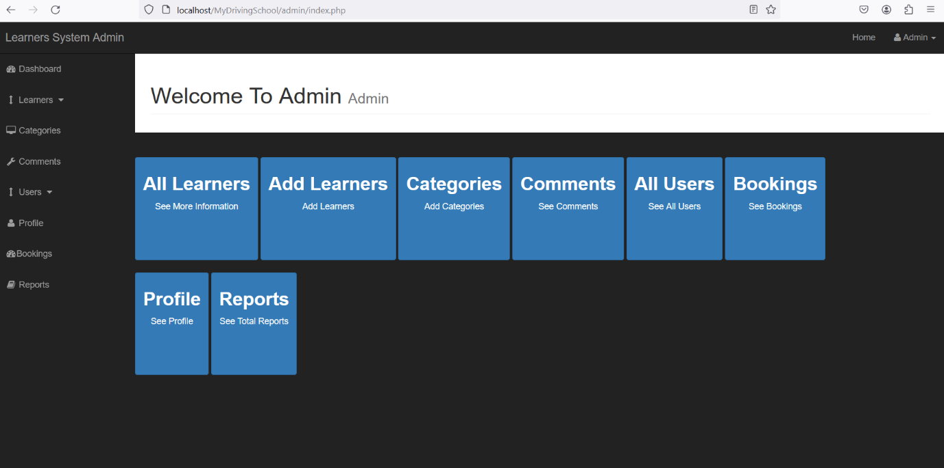

**7.Advantages**

Open-source and Free-to-use. PHP is an open-source language, which means it is free to use by developers.Easy to Learn and Use. PHP has a vast set of tutorials, resources, and other insights that anyone can use to learn this language effortlessly.Platform Independent.

HTML: It establishes the foundation of a web page by organizing and structuring the content. It defines headings, paragraphs, images, links, lists, tables, forms, and other structural elements.

CSS: It enhances the appearance of the web page by applying styles to the HTML elements.

It is platform-independent. PHP-based applications can run on any OS like UNIX, Linux, Windows, etc. Applications can easily be loaded which are based on PHP and connected to the database.

It’s mainly used due to its faster rate of loading over slow internet speed than other programming language.

It has less learning curve because it is simple and straightforward to use. Someone familiar with C programming can easily work on PHP.

It is more stable for a few years with the assistance of providing continuous support to various versions.

It helps in reusing an equivalent code.

**8.Disadvantages**

Limited interactivity: While HTML and CSS can create a static web page, they lack the ability to create more advanced interactions that JavaScript can provide. Without JavaScript, it's difficult to create animations, user input validation, and real-time updatet is not that secure due to its open-source, because the ASCII text file is often easily available.

It is not suitable for giant content-based web applications.

It has a weak type, which can cause incorrect data and knowledge to users.

PHP frameworks got to learn to use PHP built-in functionalities to avoid writing additional code.

Using more features of PHP framework and tools cause poor performance of online applications.

PHP doesn’t allow change or modification in the core behavior of online applications.

The PHP frameworks aren’t equivalent in behavior so does their performance and features.

While PHP may be a powerful tool supported by an outsized community and plentiful reference documentation, there are easier programming languages for web apps.

**9.Conclusion**

Thus,we created responsive website using php,html,css.Included form,google maps,and database integration as well.

**10.References**

Medium-Sapph Dek

Tutorialspoint

<https://www.geeksforgeeks.org>

<https://www.skillvertex.com>

**LIST OF FIGURES**

|  |  |  |
| --- | --- | --- |
| **SR. NO.** | **NAME OF FIGURES** | **PAGE NO:** |
| 1 | Web application diagram | 2 |
| 2 | XAMPP Installation | 4 |
| 3 | XAMPP Installation | 5 |
| 4 | XAMPP Installation | 6 |
| 5 | Head code of html screenshort | 7 |
| 6 | Php folder file contained screenshort | 7 |
| 7 | phpmyadmin | 8-11 |
| 8 | Code(config.php) screenshort ,dataflow diagram | 11-12 |